# Algorithm for file updates in Python

## Project description

I am developing a Python script that reads a list of allowed addresses from a file, removing IPs that no longer have access, and writes the updated list back to the file.

## Open the file that contains the allow list

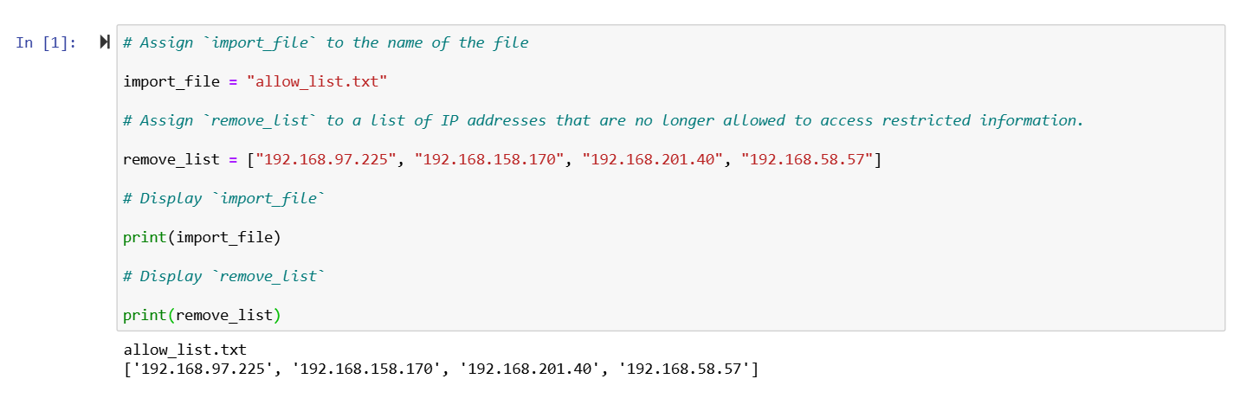

## Read the file contents

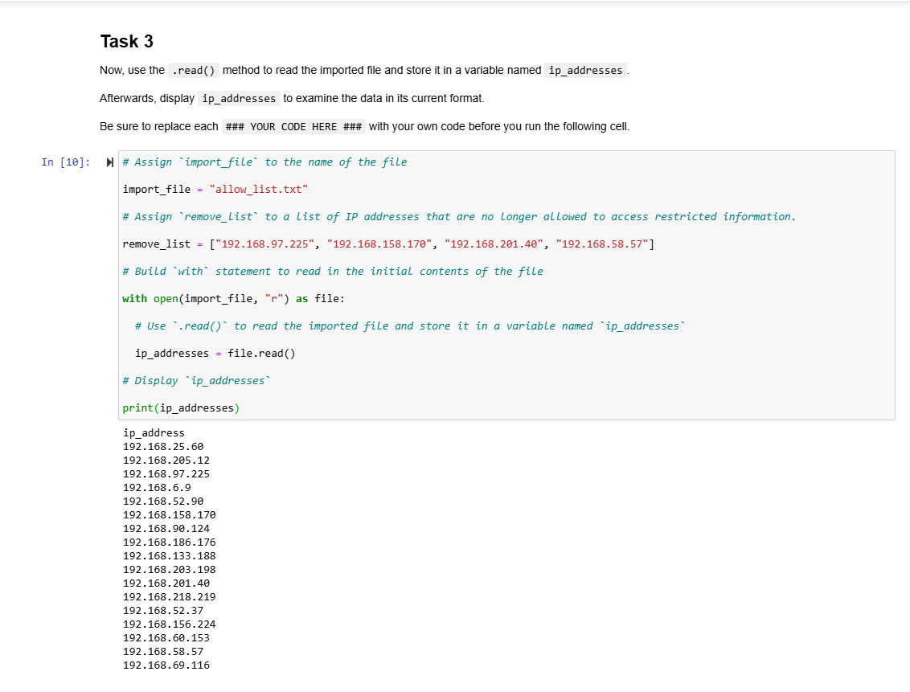

## Convert the string into a list

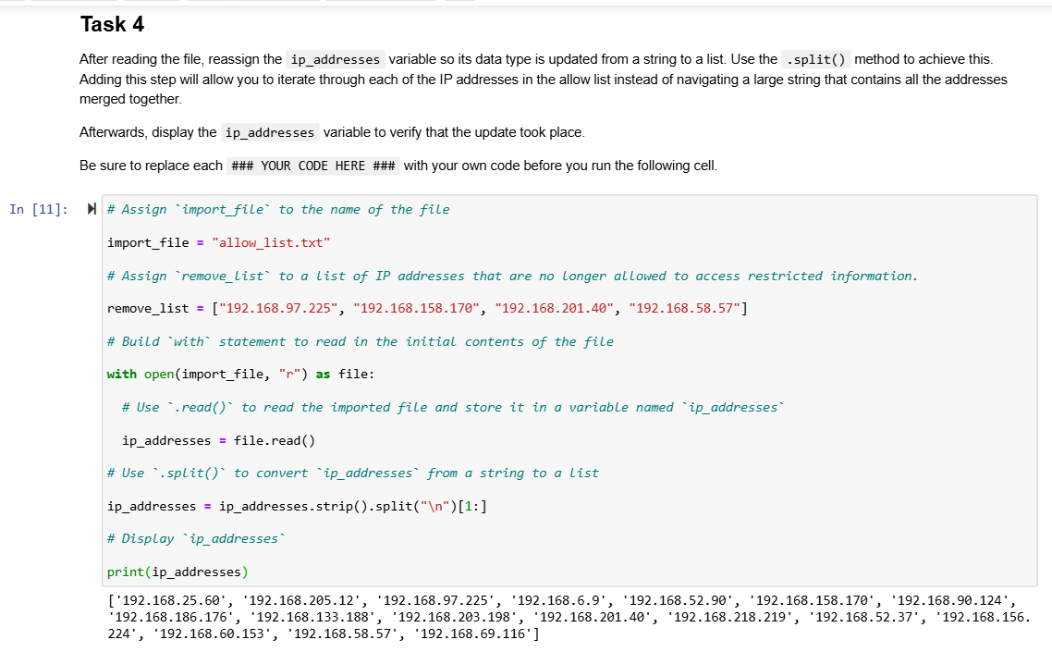

## Iterate through the remove list

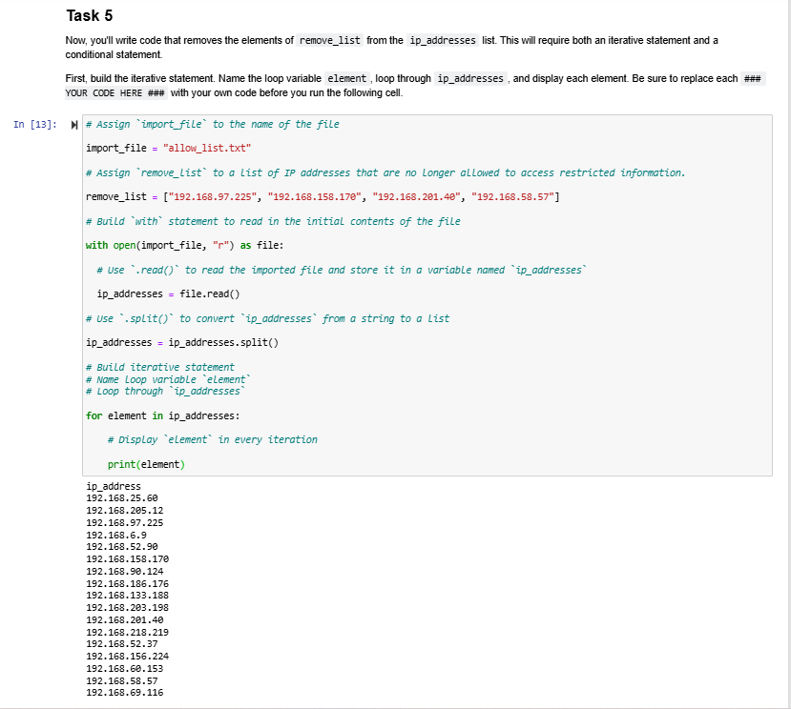

## Remove IP addresses that are on the remove list

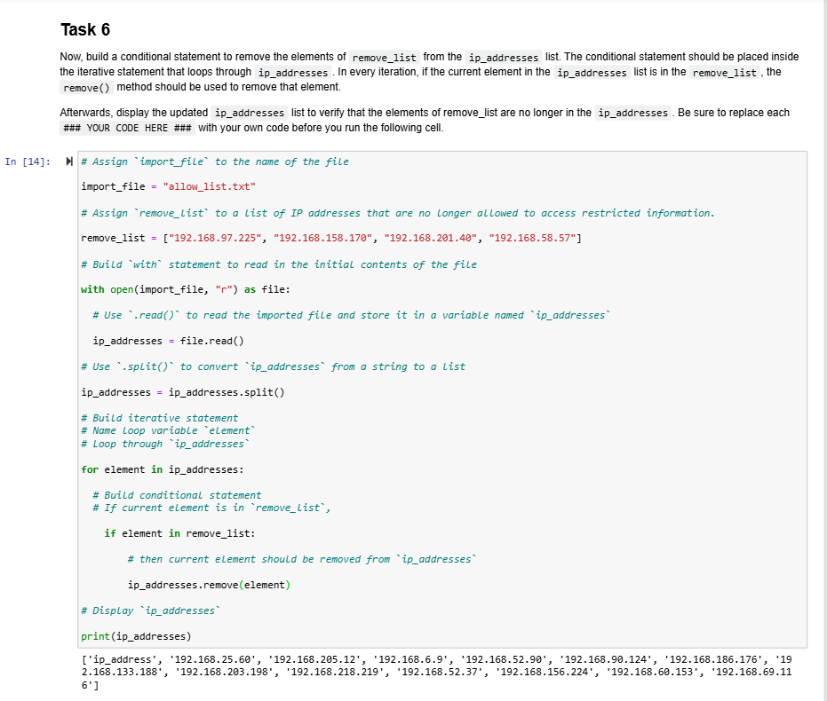

## Update the file with the revised list of IP addresses

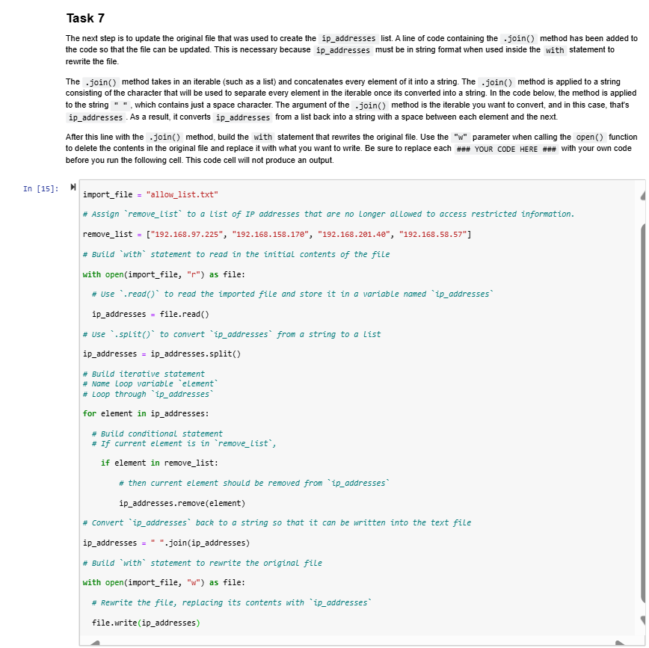

## Summary

In this lab, I learned how to use Python to automate file handling tasks, including reading, updating, and writing text files. I practiced using loops, conditionals, and list operations to filter data and gained experience structuring reusable code using functions.